Technical Design Document

Client: viettridao

Project: Work Log System

Author : TuND

# Revision History

| Version | Date | Author | Change |
| --- | --- | --- | --- |
|  |  |  |  |
|  |  |  |  |
|  |  |  |  |

**1 . Technology details project**

**1.1 Programming language**

* Server : Java version 8.
* Client : HTML 5.

**1.2 Developing Web Application**

Use Spring Boot Framework for developing Web Applicaton.

**1.2.1 Back-end**

* Spring Boot version 2.3.0.
* Controller layer : Spring MVC.
* View : ThymeLaef.
* File Configuration : application.properties

**1.2.2 Database**

* Management system : SQL Server.
* ORM Framework : Hibernate version 4.3.11.Final
* Configuration :
  + User : sa
  + Password : Poi)9876
  + Database Name : ProjectWLS
  + Address:port => localhost:1433

**1.2.3 Font-end.**

* Enent Handing : jQuery version > 3.3.1
* Interface : Bootstrap version 4.5.0
* Form Handing : Use the HTML form tag mixed with Thymeleaf attributes.
* Get Data From Server : AJAX in libraly jQuery > 3.3.1
* CSS Preprocessor : #
* Form Validation : Java Bean validation API provided by Spring MVC.

**1.2.4 Name**

* ***Source code naming convention:***

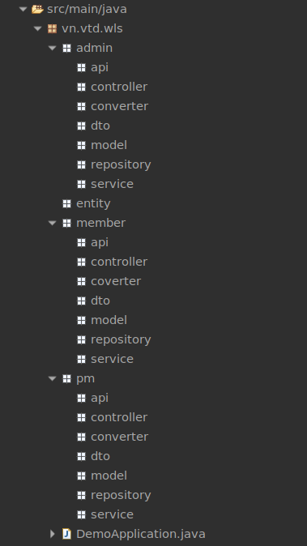

* ***Prototype naming convention:***

**(WAIT SRS)**

|  |  |  |  |  |
| --- | --- | --- | --- | --- |
|  | | | | |
| SRS | Name Screen | Title Screen | CSS Name | JS Name |
|  | WLS_AD01 | Home | WLS-AD01CSS | WLS-AD01JS |
|  | WLS-AD0101 | Manage Member | WLS-AD02CSS | WLS-AD02JS |
|  | WLS-AD0102 | Manege Projects | WLS-AD02CSS | WLS-AD02JS |
|  |  |  |  |  |
|  | WLS-PM01 | Home | WLS-PM01CSS | WLS-PM01JS |
|  | WLS-PM02 | My Projects | WLS-PM02CSS | WLS-PM02JS |
|  | WLS-PM0201 | Manage Projects | WLS-PM0201CSS | WLS-PM0201JS |
|  | WLS-PM020101 | Manage Member | WLS-PM020101CSS | WLS-PM020101JS |
|  | WLS-PM020102 | Manage Product | WLS-PM020102CSS | WLS-PM020102JS |
|  | WLS-PM020103 | Review Logwork | WLS-PM020103CSS | WLS-PM020103CSSJS |
|  |  |  |  |  |
|  | WLS-MB01 | Home | WLS-MB01CSS | WLS-MB01JS |
|  | WLS-MB02 | My Projects | WLS-MB02CSS | WLS-MB02JS |
|  | WLS-MB0201 | All Log Work | WLS-MB0201CSS | WLS-MB0201JS |
|  | WLS-MB0203 | My Log Work | WLS-MB0203CSS | WLS-MB0203JS |
|  |  |  |  |  |

**1.2.5 Other**

* File deploy : jar
* IDE : Spring Tool Suite 3.9.11
* Maven : > 3.3.6